**BASERA HOTEL MANAGEMENT SYSTEM**

BASERA hotel, Ramanreti, Vrindavan

2019

6/24/2019

**BASERA HOTEL**

BASERA Hotel offers accommodation, meals, additional facilities and other services.

Accommodation services are offered as follows:

|  |  |  |  |
| --- | --- | --- | --- |
| Category | Bed & Breakfast | Half board | Full board |
| Single Room | 2500 | 3900 | 5100 |
| Double Room | 2900 | 4300 | 5500 |
| Single Room Self Contained | 3100 | 4500 | 5700 |
| Double Room Self Contained | 3700 | 5100 | 6300 |

Meals, other services and facilities offered includes: Breakfast; Lunch, dinner, tea, Laundry, Ironing, transport and room service.

The services are offered as outlined below:

|  |  |
| --- | --- |
| Item | Cost |
| Breakfast | 1000 |
| Lunch | 700 |
| Dinner | 1500 |
| Tea | 250 |
| Laundry: Heavy Linen, Medium, Light | 300, 200, 100 |
| Transport: Mileage, Vehicle |  |

The hotel is of an international class and quality. Currently hotel is using manual system to manage all things.

**THE CURRENT MANUAL SYSTEM**

The current manual system uses paperwork and direct human language communication by mouth to manage the hotel. This delays information transmission in the hotel. Booking is done through phone calls or through visit to the hotel booking office. The guest’s personal details such as Name, Age, Nationality, and Duration of stay, are input during booking in. The booking office orders for preparation of the guest’s room before his/ her check in date. The documents are transferred manually to the filling department for compilation of the guest’s file. On the reporting date the file is transferred to the reception. On checking in the guest is given the key to his allocated room, he also specify if he needs room service. The receptionist hands over the guest’s file to the accountant on the next table. Here the guest pays accommodation and meals fee. The guest’s file is updated on daily basis of his expenditure costs. The accounts department generates the bills on daily basis and delivered to the guests in their rooms at dusk by the service maids. The guest pays at the accounts desk, where the receipts are generated. For a one meal customer the bill is generated immediately after ordering and he pays at the accountant desk before leaving. During checking out of guests, their expenditure outlines are generated a day before check out date. The guests receive their outlines at the accounts desk as they check out, where they pay for bills balances if any.

**PROBLEMS IN THE MANUAL SYSTEM**

* Difficulty in location of guest files
* Large storage space
* Human and computational errors
* Poorly generated records
* Complains from guests
* Poor communication
* Difficulty in data analysis

**DISADVANTAGES OF THE MANUAL SYSTEM**

* Guest files can easily get lost or mix up with other guest file documents.
* Files occupy a large storage space.
* Unnecessary duplication of data.
* Files are prone to theft unauthorized modification due to low data security levels and standards.
* Due to easy access to guest data by unauthorized users, guest data is extremely unconfident.
* Retrieval of guest records is extremely difficult.
* Data entry procedure is prone to errors.
* Guest records are extremely difficult to modify since modification generates dirty and unpresentable reports.

**THE PROPOSED SYSTEM**

To avoid the problems with M**anual System** hotel decide to implement an automatic computerized and advanced system.

**OBJECTIVES OF THE PROPOSED SYSTEM**

* To enable online booking via the internet.
* To enable automated data entry methods.
* Ensure efficient and reliable communication within the hotel.
* Avoid data entry errors by use of input masks.
* Enable easy authorized modification of data.
* Enforce security measures to avoid unauthorized access to guest records.
* Enable fast and easy retrieval of guest records and data for fast reference activities.

**SCOPE OF THE SYSTEM**

The system will cover; booking, accommodation, meals, and accounts details. Moreover, special services such as laundry, ironing and room service will be automated by the system also.

* Booking
* Accommodation
* Admission
* Meals
* Laundry
* Ironing
* Transport
* Ambulance
* Conference
* Swimming pool facility
* Sporting facility
* Employees details

**THE ADVANTAGES OF THE SYSTYEM**

* The system enables easy and fast access to the guest files.
* The system provides better data management facilities.
* The system enable online booking of guests into the hotel hence international guests can easily book into the hotel.
* The system provides performance evaluation of the employees to ensure maximum output from the employees.
* The system provides security measures to access to the hotel’s information lowering data security threats.
* The system help reduce the congestion of guests ensuring best service output for customer satisfaction purposes.
* Easy update of the guest records.
* High customer service standards attract more guests to the hotel.
* Reduction of data entry and processing errors.
* Greatly reduce paper use at the hotel.

**THE DISADVANTAGES OF THE SYSTEM**

* The system will undergo system entropy hence an extra cost of updating will be incurred to keep the system competitive in the ICT and BUSSINESS world.
* The hotel will incur an extra cost on the electricity and internet bills due to computerization of the hotel management.
* The hotel will be required to train its employees on how to manage the system hence the hotel output capacity will reduce a bit during this period.

**THE SYSTEM DESIGN**

The system was designed in Microsoft Access package. The system design phase describes the functional capabilities of the proposed system. This is divided into the following design phases: System flowchart, System dataflow diagram, Input design, processing design and output design.

**SYSTEM DATAFLOW DIAGRAM**

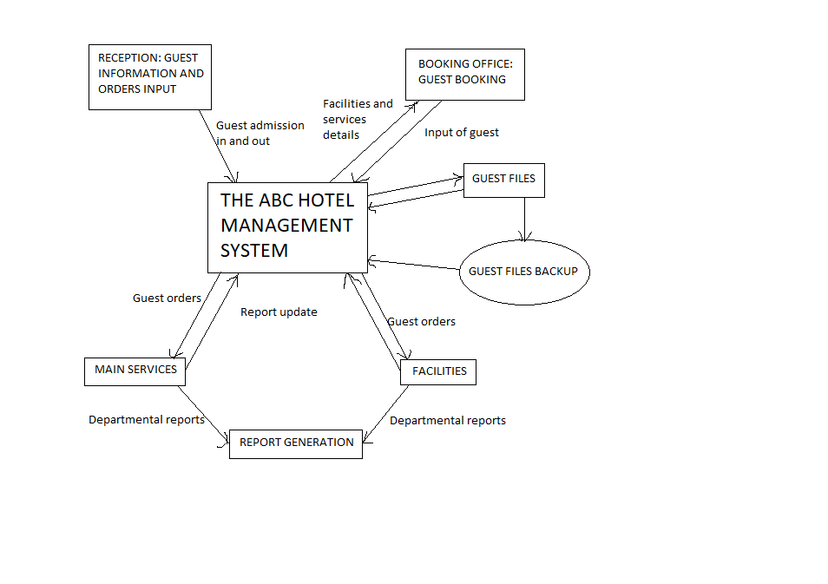

**File data**

* Booking table

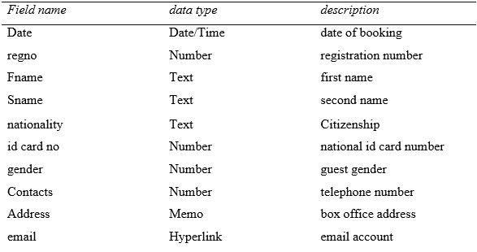

* Admission Table

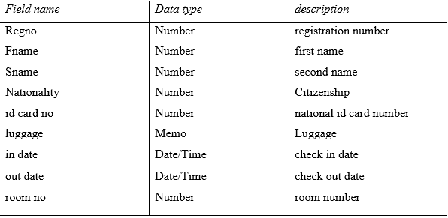

* Meals table

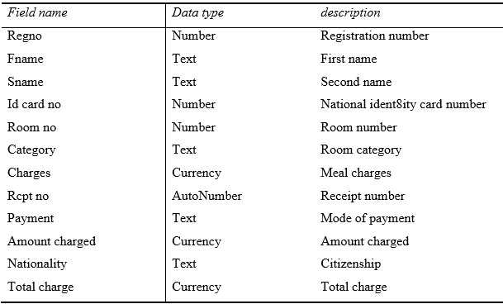

* Ironing table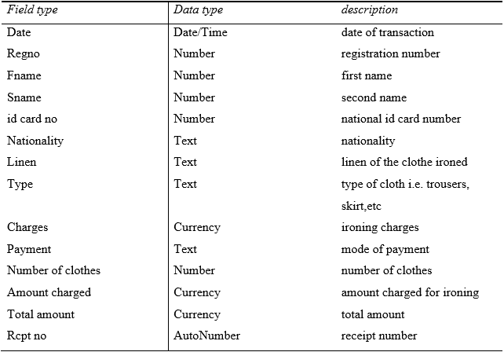
* Transport table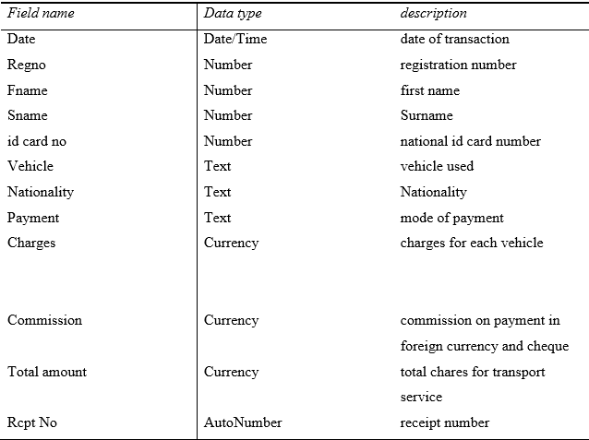
* Conference table

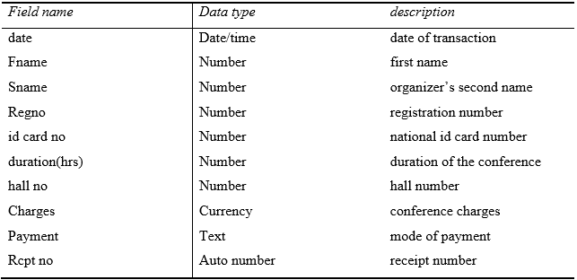

* Sporting table

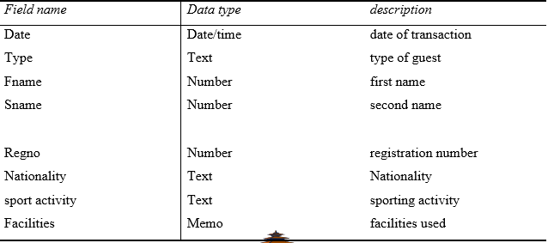

* Employees details table

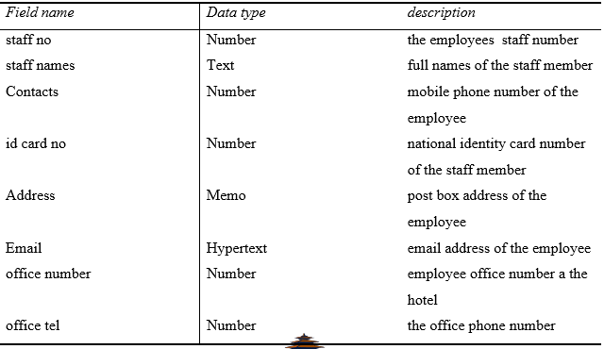

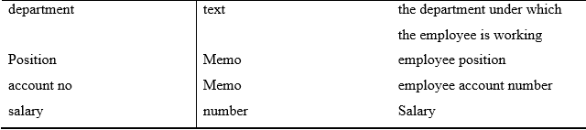

**Input design**

* **Booking form**

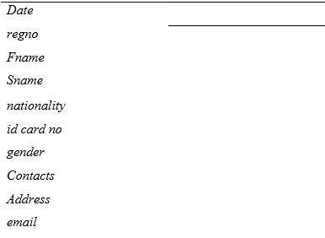

* **Admission form**

Regno, Fname, Sname, Nationality, id card no, luggage, in date, out date, room no

* **Accommodation form**

Fname, Sname, Id card no, Room no, Category, Charges, Rcpt no, payment, Amount charged nationality, Total charge

* **Meals form**

Regno, Fname, Sname, Id card no, Room no, Category, Charges, Rcpt no, Payment, Amount charged, Nationality, Total charge

* **Laundry form**

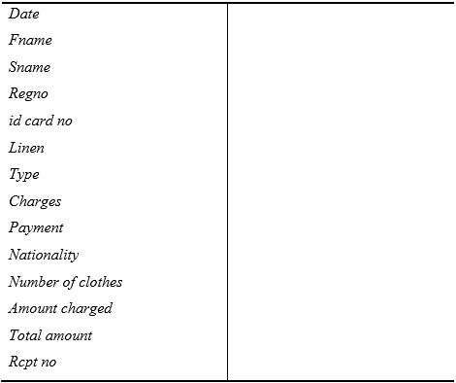

* **Ironing form**

Date, Regno, Fname, Sname, id card no, Nationality, Linen Type, Charges, Payment, Number of clothes, Amount charged, Total amount, Rcpt no

* **Transport form**

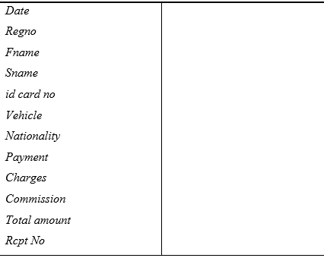

* **Sporting form**

Date, Type, Fname, Sname, Regno, Nationality, sport activity, Facilities, Duration, Charges, Payment, Total amount, Rcpt no

* **Swimming pool form**

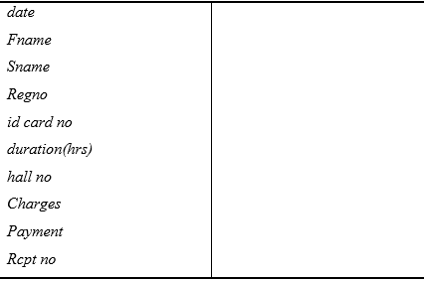

* **Ambulance form**

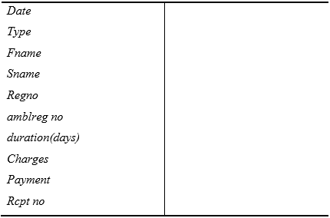

* **Employee details form**



staff no, staff names, Contacts, id card no, Address, Email, office number, office tel, department, Position, account no, salary

* **Conference form**

Date, guest type, Regno, Fname, Nationality, duration(hrs), Charges, Payment, no of guests, Total amount, Rcpt no

**System controls, backup and security**

**Protection from viruses**

Installation and frequent updating of latest Antivirus programs is recommended to ensure the most security against viruses.

**Data security measures**

During data transmission data should be encrypted and decrypted at the back up centre. Access privileges shall be enacted to control access of users to valuable data and information to uphold data security. Burglar proof windows should be installed on data storage and backup rooms. Guards should be employed to watch over both hardware and software resources at the hotel. Alarm systems should be installed to detect and alarm the security of unauthorized entry into the information storage rooms. Direct capture (CCTV) cameras should be used for surveillance at the hotel.

**Audit trial**

Serious study and –revision of the system has been –done, checking for any loophole which could be a possible weak point into the hotel management system.

**log files**

The logs files shall be used to keep record on which employee accessed the system at what time what the employee accessed and modified. The employees shall only access the system resources using their passwords.

**Policies**

The system analyst recommends that the hotel management should enforce the following policies:

* No transfer of guest information from the system at any time under any circumstances without written permission from the management.
* No opening of any mail attachment without scanning for viruses and threats.
* No use of diskettes within the hotel.

**SYSTEM CONSTRUCTION**

* Tables
* Queries
* Forms
* Reports
* Macros

**Instillation requirements**

* Operating system- Windows 2007 or Vista
* Microsoft office 2007
* 3 GHz processor
* 4 GB RAM
* 500 GB hard disk
* DVD drive
* Antivirus

**SYSTEM IMPLEMENTATION**

This is a phase in which the system analyst did an evaluation of the changeover method that should be used to switch from present manual system to the developed computerized system. After a close analysis the analyst came up with parallel changeover method as the most appropriate for the system. Parallel method is whereby the computerized system will run concurrently with the manual system before discarding the manual system. Although expensive the changeover method will prove to be the most efficient because:

* Parallel changeover provides time for one the database administrator to update all the guest files before a total changeover to the new system.
* It’s possible to troubleshoot any errors arising from loading process without affecting the hotel’s transactions as the manual system will still be in place to carry out the hotel activities smoothly.
* Provides time for employees to learn and adapt to the new system.
* Lowers the risk to the management in case of a technical hitch or breakdown as the manual system will still be in place as the analyst fixes the technical hitch.

**SCREEN SHOT**

**HOME PAGE**

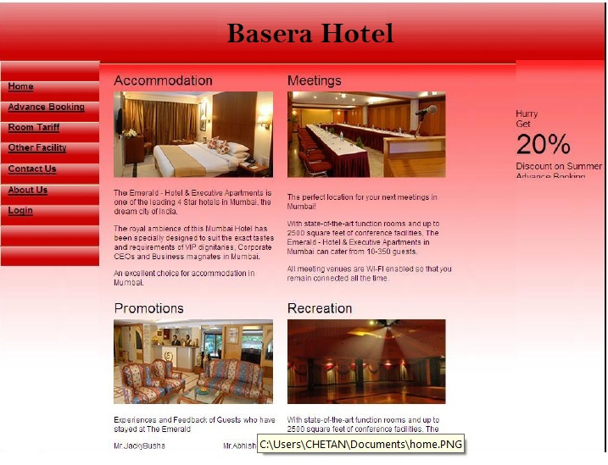

**LOGIN PAGE**

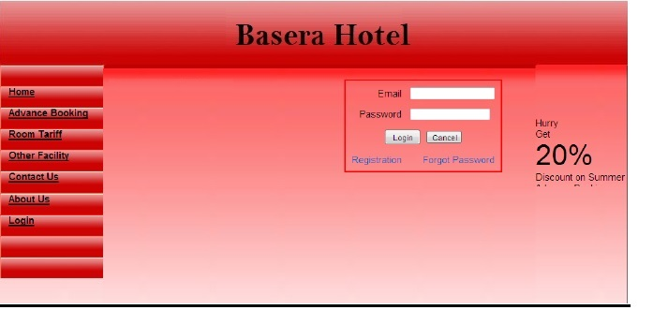

**ADVANCE BOOKING**



**ROOM TARIFF**

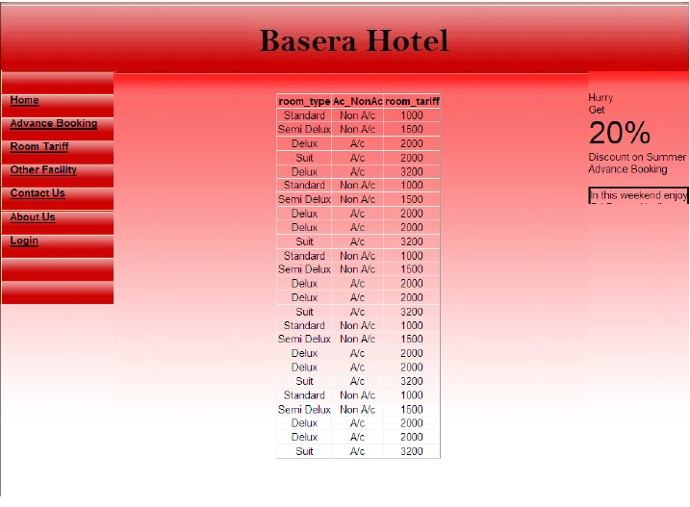

**AFTER LOGIN**

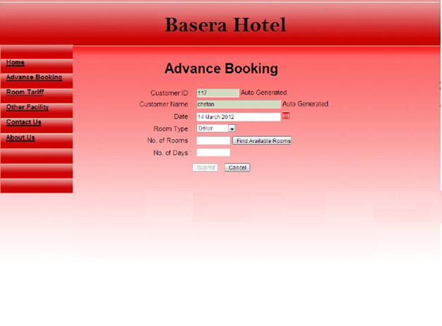

**ADVANCE BOOKING**

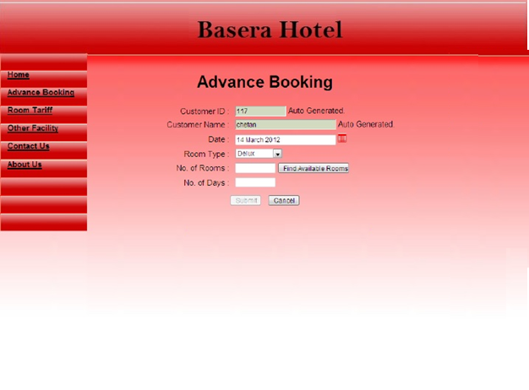

**GLOSSARY**

* KSH Kenya shillings
* regno registration number
* fname first name
* sname second name
* id card no identity card number
* email electronic mail
* Room no room number
* ext extension
* Rcpt no receipt number
* amblreg no ambulance registration number
* hrs hours
* tel telephone
* ICT Information communication technology
* KNEC Kenya national examination council
* etc etcetera
* GHz gigahertz
* MB megabytes
* RAM random access memory
* GB gigabytes
* CD compact disk
* DVD digital versatile disk
* ILRI international livestock research institute
* Dr doctor

**CONCLUSION**

Finally we have a develop system that would computerize the ABC hotel activities, the system analyst has been able to come to a successful end of a journey that has seen him through ups and downs. This will be helpful to manage the whole system.